CONTROL UNIT
AUS X SERIES
INSTALLATION USE AND MAINTENANCE

INDEX

AUS X CONTROL UNIT 4
OPERATING MODES DESCRIPTION 4
AUTOMATIC 4
MANUAL 5
CONNECTION OF EXTERNAL CONTACTORS K1 and K2 5
CONNECTON EXAMPLES 6
CONNECTION OF AUS X WITH 2 COUPLES OF ULISSE/ILION PHOTOCELLS (WITHOUT K1K2 EXTERNAL CONTACTORS) 6
SERIES CONNECTION OF AUS X WITH 2 COUPLES OF ULISSE/ILION PHOTOCELLS (WITH K1K2 EXTERNAL CONTACTORS) 7
CONNECTION OF AUS X WITH 4 COUPLES OF ULISSE/ILION PHOTOCELLS (WITHOUT K1K2 EXTERNAL CONTACTORS) 8
SIGNAL DESCRIPTION 9
The RESTART command 9
The SYSTEM_TEST command 10
K1K2 FEEDBACK input 10
SYSTEM STATUS output 10
INSTALLATION AND ELECTRICAL CONNECTIONS 10
Characteristics of the output circuit. 11
Use of K1 and K2 auxiliary contact elements. 11
Warnings regarding the connection cables. 11
STATUS INDICATORS 12
DIMENSIONS 12
TECHNICAL DATA 13
Status indicators with 1 photocell 13
Status indicators with 2 photocells 14
FAULT DIAGNOSIS 14
MODULO AUS XM 15
OPERATING MODES DESCRIPTION 15
AUTOMATIC 15
MANUAL 16
CONNECTION OF EXTERNAL CONTACTORS K1 and K2 17
CONNECTON EXAMPLES 18
CONNECTION OF AUS XM WITH 2 COUPLES OF ULISSE/ILION PHOTOCELLS (MANUAL MODE, WITH K1K2 EXTERNAL CONTACTORS, TIMEOUT MUTING = 30s) 18
CONNECTION OF AUS XM WITH 2 COUPLES OF ULISSE/ILION PHOTOCELLS IN SERIES (MANUAL MODE, WITH K1K2 EXTERNAL CONTACTORS, TIMEOUT MUTING = 30s) 19
CONNECTION OF AUS XM WITH 4 COUPLES OF ULISSE/ILION PHOTOCELLS IN SERIES (AUTOMATIC MODE, TIMEOUT MUTING = ∞) 20
MUTING FUNCTION 20
Muting sequence 21
MUTING OVERRIDE FUNCTION 22
Override with maintained action control 23
Override with pulse control 23
SIGNALS DESCRIPTION 24
The RESTART command 25
The SYSTEM_TEST command 25
K1K2 FEEDBACK input 26
SYSTEM STATUS output 26
INSTALLATION AND ELECTRICAL CONNECTIONS 26
Characteristics of the output circuit. 26
Use of K1 and K2 auxiliary contact elements. 27
Warnings regarding the connection cables. 27
STATUS INDICATORS 28
DIMENSIONS 28
TECHNICAL DATA 29
Status indicators with 1 photocell connected 30
Status indicators with 2 photocells connected 30
Status indicators (MUTING module) 30
Fault diagnosis 31
Fault diagnosis (modulo MUTING) 31
GUARANTEE 32

- This symbol indicates an important personal safety warning. Failure to comply with the warning may result in very high risk for exposed personnel.
INTRODUCTION
The ReeR AUS X control unit is a safety device complying with IEC 61496-1, IEC 61496-2 specifications. When connected to a Ilion or a ULISSE/ILION UPC safety photocell, it forms a type 2 ESPE (Electro-sensitive Protective Equipment).

The AUS X main features are the following:
- Possible connections: from 1 to 4 photocells
- Restart manual or automatic selectable
- 2 N.O. outputs with guided contact safety relays
- 1 system monitor PNP output
- 1 external contactors feedback input
- Connected safety photocells periodic autotest (every 20s) .
The AUS XM main features are the following:
- Possible connections: from 1 to 4 photocells
- Manual or automatic selectable Restart
- 2 N.O. outputs with guided contact safety relays
- 1 system monitor PNP output
- 1 external contactors feedback input
- Muting function with two sensors logic
- 1 Muting function enable input
- 1 muting lamp output
- Muting Override function integrated
- Selectable muting timeout
- Connected safety photocells periodic autotest (every 20s).
The control unit also guarantees that:
- the output lines are open if the photocell is intercepted;
- the output lines are enabled only with correct response times;
- in manual mode, maintenance of the RESTART contact closed is not interpreted as AUTO mode.

- For safe use of the device, it is essential to read and understand the contents of this handbook.
- Failure to comply with the prescriptions indicated in this handbook may result in very high risks for the operating personnel of the machine protected.

- Carefully consider the risks analysis of the application and the legislation of the barrier application Country to establish if the application is compatible with the safety category 2.

AUS X CONTROL UNIT
OPERATING MODES DESCRIPTION

OPERATING MODES SELECTION
TERMINAL 5 | TERMINAL 4 | OPERATION
0 Vdc | +24 Vdc | Automatic
+24 Vdc | +24 Vdc through a N.O. contact | Manual
0 Vdc | 0 Vdc | Non-permissible  conditions
+24 Vdc | +24 Vdc | Non-permissible  conditions
Table 1

AUTOMATIC
In this operating mode, the outputs of the control unit follow the status of the photocell:
  - with the protected area free (outputs of the photocells active), the relay outputs of the control unit are active.
  - with the protected area occupied (outputs of the photocells de-activated), the relay outputs of the control unit are de-activated.

Figure 1

- Use in manual mode (start/restart interlock activated) is mandatory in the case in which the safety device controls an access protecting a danger zone and once a person has passed through the opening, he/she may remain in the danger zone without being detected (use as trip device according to IEC 61496). Failure to comply with this rule may result in very serious risks for the persons exposed.
- Check correct functioning of the entire safety system (control unit+photocell) following each re-installation. In particular, if the original operating mode was Manual, check that the unit has been reconfigured in this mode.

MANUAL
In this operating mode, the outputs of the control unit are activated only if the protected area is free and after sending the RESTART signal to the control unit using the push-button or by means of a specific command on the RESTART input (terminal 4).
Once the protected area has been occupied, the relay outputs are de-activated. The sequence described above must be repeated in order to re-activate them.
The RESTART command is active with a 0VDC ---> +24VDC transition.
The minimum duration of the command is 100 ms.

Figure 2

CONNECTION OF EXTERNAL CONTACTORS K1 and K2
Control of external contactors K1K2 can be activated in both operating modes. If this control must be used, the series of normally closed contacts of the external contactors must be connected to terminal 11 of the control unit (figures 3 and 4).

Figure 3
Automatic functioning with K1K2 relays

Figure 4
Manual functioning with K1K2 relays

CONNECTON EXAMPLES

CONNECTION OF AUS X WITH 2 COUPLES OF ULISSE/ILION PHOTOCELLS (WITHOUT K1K2 EXTERNAL CONTACTORS)
Figure 5

SERIES CONNECTION OF AUS X WITH 2 COUPLES OF ULISSE/ILION PHOTOCELLS (WITH K1K2 EXTERNAL CONTACTORS)

Figure 6

- In this case, the 2 photocells are connected in series and the INPUT BARR2 (terminal 8) is not utilized; this signal must be connected to the TEST BARR2 (terminal 10).

CONNECTION OF AUS X WITH 4 COUPLES OF ULISSE/ILION PHOTOCELLS
(WITHOUT K1K2 EXTERNAL CONTACTORS)

Figure 7

SIGNAL DESCRIPTION

TERMINAL  NUMBER | SIGNAL  NAME | TYPE OF  SIGNAL | DESCRIPTION
1 | 24VDC |  | Power supply 24Vdc
2 | 0VDC |  | Power supply 0Vdc
3 | PE |  | Ground connection
4 | RESTART | Input | Restart command
5 | MAN/AUTO | Input | Manual/Automatic Configuration
6 | SYSTEM_TEST | Input | Test of the system external request
7 | INPUT BARR1 | Input | Safety photocell number 1  status input
8 | INPUT BARR2 | Input | Safety photocell number 2  status input
9 | TEST_BARR1 | Output | Safety photocell number 1 TEST
10 | TEST_BARR2 | Output | Safety photocell number 2 TEST
11 | K1K2 (Feedback) | Input | Feedback external contactors K1K2
12 | SYSTEM STATUS | Output | Output status
13 | Relay B NO1 | Output | Safety relay B, contact 1 (N.O.)
14 | Relay B NO2 | Output | Safety relay B, contact 2 (N.O.)
15 | Relay A NO1 | Output | Safety relay A, contact 1 (N.O.)
16 | Relay A NO2 | Output | Safety relay A, contact 2 (N.O.)
Table 2

The RESTART command
- The RESTART command must be sent to the control unit connecting terminal 4 to the +24Vdc.
- The contact used for the RESTART command must be able to switch a voltage of 24Vdc and a current of 20mA (guaranteeing a closing time > 100ms). This data is particularly important in the case of automatic management of the RESTART command sending, for example using a PLC.
- The SYSTEM RESET TIME is obtained adding the reset time of any external contactors K1K2 to the reset time of the AUS X control unit (100ms).
- In the case of manual activation, a normally open external button can be used, temporary closing of which generates the RESTART command.

- The Restart control must be installed outside the danger area in a position where the danger area and the entire work area concerned are clearly visible.
- It must not be possible to reach the control from inside the danger area.

The SYSTEM_TEST command
The SYSTEM_TEST command must be forwarded to the control unit connecting the terminal 6 to the +24Vdc.
The contact used for the SYSTEM_TEST command must be able to switch a current of 20mA and a voltage of 24Vdc (with a switching time of >40ms). The AUS X control unit, after receiving this signal, provides to switch off the emitters of the connected safety photocells, THUS SIMULATING AN INTERCEPTION OF THE PROTECTED AREA.
The operator must verify the effective stopping of the hazardous machine (due to the de-activation of the control unit outputs) for all the time the SYSTEM_TEST command stays active.

- The effective stopping of the system must be verified by an operator and cannot be an operation of the control unit.

K1K2 FEEDBACK input
Using the K1 and K2 auxiliary safety contactors with guided contact safety type, it is necessary to connect the +24Vdc to the K1K2 FEEDBACK through the series of the K1-1 e K2-1 N.C. control contacts. The control of the correct switching of K1 and K2 is performed with a delay of 300ms after the real command.
When the K1-1 e K2-1 N.C. control contacts are not used (or no control is provided) it is mandatory to connect the terminal 11 (K1K2 FEEDBACK) to the terminal 12 (SYSTEM STATUS).

SYSTEM STATUS output
The SYSTEM STATUS output reports exactly the output safety relays status :
- When the output relays are opened, the SYSTEM STATUS reports 0VDC.
- When the output relays are closed, the SYSTEM STATUS reports +24VDC.

INSTALLATION AND ELECTRICAL CONNECTIONS
- Install the AUS X control unit in an environment with a protection rating of at least IP54.
- If more modules AUS X must be installed in the same board panel, in order to avoid overheatings, maintain between them one minimal distance of 2cm.
- The AUS X control unit must be supplied with a 24Vdc ±20.
- The external power supply must comply with the standard EN 60204-1.
- During the installation of the AUS X control unit be sure to avoid short circuits between the contacts 7 and 8.

Characteristics of the output circuit.
For the output circuit, the control unit uses two guided contact safety relays.
These relays are rated by the manufacturer for voltage and current values above those indicated in the technical data; however, to assure correct insulation and to avoid damage or premature aging, protect each output line with a 4A slow-blow fuse and check that load characteristics comply with the indications given in the table below.

Minimum switching voltage | 18 Vdc
Minimum switching current | 20 mA
Maximum switching voltage | 250Vac
Maximum switching current | 2A

Use of K1 and K2 auxiliary contact elements.
For loads with higher voltage and current characteristics than those indicated in the table above, use of auxiliary external relays or contactors suitable for the load to be controlled is recommended.
- The K1 and K2 auxiliary contactors or relays must be of the guided contact safety type.
- Referring to the table below, pay particular attention to the configuration of the control contacts on terminal 11 and that of the contacts of use.

 | Relay K1 | Relay K2
Control contacts | K1-1 normally closed | K2-1 normally closed
Use contacts | K1-2 normally open | K2-2 normally open

- Control contacts K1-1 and K2-1 (terminal 11) must be able to switch a current of 20mA and a voltage of 24Vdc.
- To increase the electrical life of internal relays A and B, it is advisable to use anti-disturbance devices which must be connected across the coils of K1 and K2.

Warnings regarding the connection cables.
- For light curtain/control unit connections of more than 50m, cables with a cross-section of at least 1mm2 must be used.
- It is good practice to separate the power supply of the control unit from that of other electrical appliances (electrical motors, inverters, frequency variators) or other sources of disturbance.
- The path of the connection cables between the control unit ands the sensors, the connection referring to the test command and feedback contacts connected to terminal 11 must be different from that of other power cables.

STATUS INDICATORS

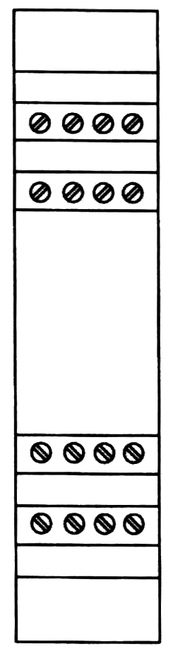
5 6 7 8
1 2 4
13 14 15 16
9 10 11 12
IN1

IN2
FAIL

GUARD
BREAK
AUS X
LED | COLOR | STATUS | CONDITION
IN1 | Green | ON | Photocell 1 free
IN1 | Green | OFF | Photocell 1 intercepted
IN2  FAIL | Green/  Red | RED | Fault detected *
IN2  FAIL | Green/  Red | GREEN | Photocell 2 free
IN2  FAIL | Green/  Red | OFF | Photocell 2 intercepted or absent
GUARD  BREAK | Green/  Red/  YELLOW | RED | Output relays opened
GUARD  BREAK | Green/  Red/  YELLOW | RED  blinking | The number of blinkings shows the  kind of FAIL (only with IN2/FAIL RED) *
GUARD  BREAK | Green/  Red/  YELLOW | GREEN | Output relays closed
GUARD  BREAK | Green/  Red/  YELLOW | YELLOW | Photocells free - Output relays opened (only in manual mode)
Table 3

* REFER TO THE "FAULT DIAGNOSIS" SECTION TO HAVE A DETAILED
EXPLANATION OF THE POSSIBLE FAULT

DIMENSIONS
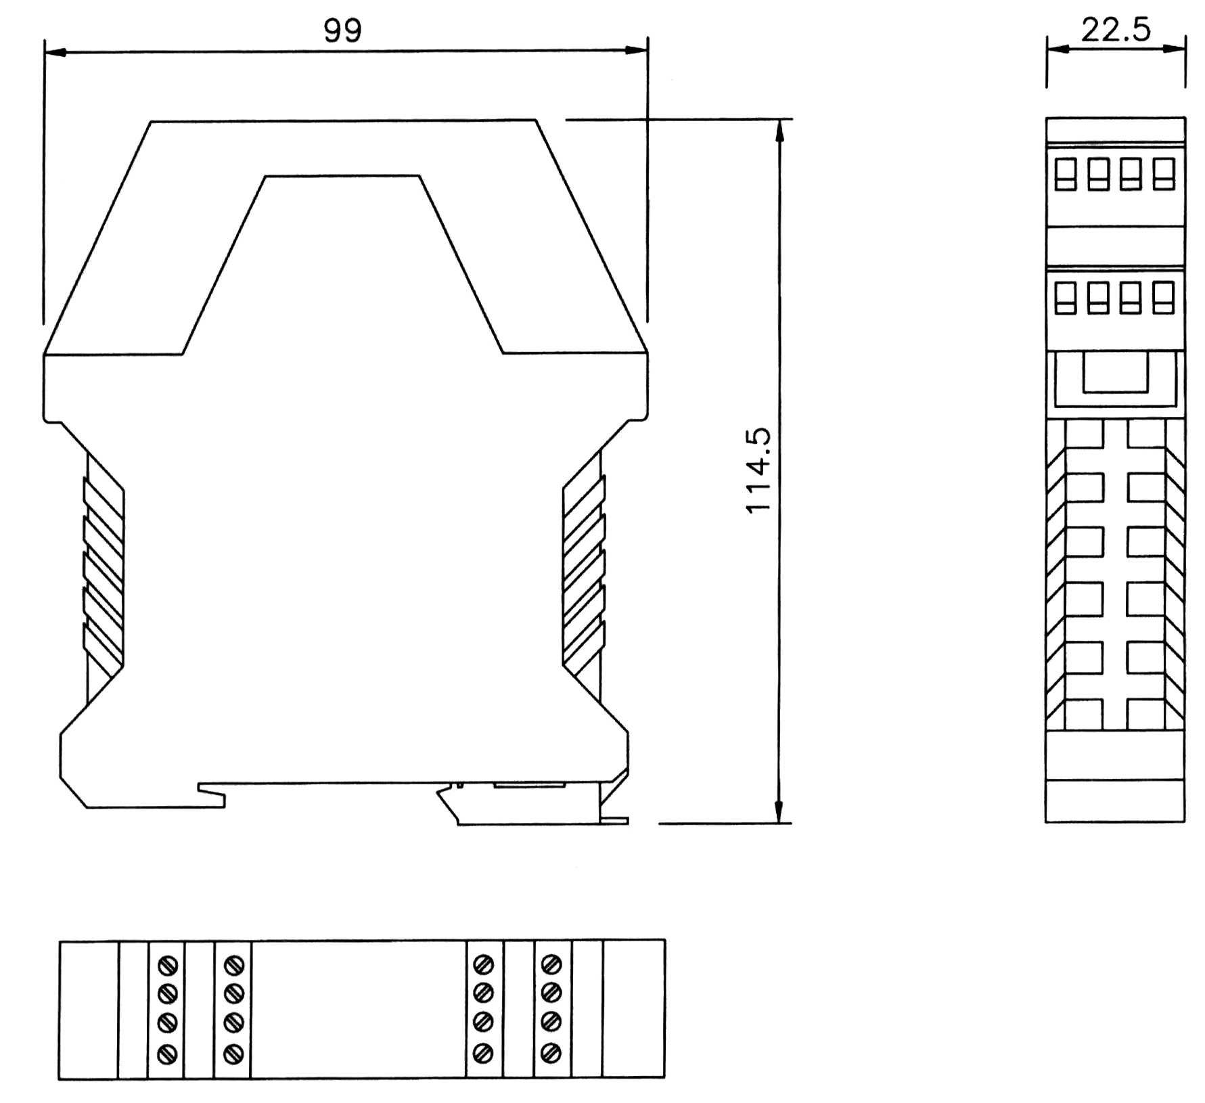
TECHNICAL DATA

Safety category |  | 2
Power supply | Vdc | 24 ± 20%
Power requirement | W | 5 max
Output | Relay | 2 N.O. contacts (2A; 250V)
Response time | ms | 30 max
Operating modes |  | Manual or Automatic, selectable  from terminal block
External relay control |  | 2 N.C. contacts (20mA; 24Vdc)
Number of connectable photocells |  | 1 ÷ 4
Connections |  | Terminal block with protection  against reversal of polarity
Status indicators | Led | Power On – Photocell Status – Fail
Max. length of connections | m | 100
Operating temperature | °C | 0 ÷ 55
Enclosure protection rating |  | IP 20
Terminal block protection rating |  | IP 2X
Fastening |  | Fast attachment to rail according  to EN 50022-35
Dimensions (h x w x d) | mm | 99 x 22,5 x 114,5
Weight | g | 150
Table 4

STATUS INDICATORS / FAULT DIAGNOSIS

Status indicators with 1 photocell

LED |  |  | MEANING
IN1  GREEN | IN2/FAIL  RED/GREEN | GUARD/BREAK  RED/GREEN | MEANING
ON | RED | RED | Power on TEST
OFF | OFF | RED | Photocell INTERCEPTED,  outputs in OFF
ON | OFF | YELLOW | Photocell FREE,  outputs in OFF
ON | OFF | GREEN | Photocell FREE,  outputs in ON
Shows the  photocell_1 status | OFF | YELLOW: blinks 2 times per second | System TEST
Table 5

Status indicators with 2 photocells

LED |  |  | MEANING
IN1  GREEN | IN2/FAIL  RED/GREEN | GUARD/BREAK  RED/GREEN | MEANING
ON | RED | RED | Power on TEST
OFF | OFF | RED | Photocell INTERCEPTED,  outputs in OFF
OFF | ON | RED | Photocell INTERCEPTED,  outputs in OFF
ON | OFF | RED | Photocell INTERCEPTED,  outputs in OFF
ON | ON | YELLOW | Photocell FREE,  outputs in OFF
ON | ON | GREEN | Photocell FREE,  outputs in ON
Shows the  photocell_1 status | Shows the  photocell_2 status | YELLOW: blinking 2 times per second | System TEST
Table 6

FAULT DIAGNOSIS

LED |  |  | MEANING
IN1  GREEN | IN2/FAIL  RED/GREEN | GUARD/BREAK  RED/GREEN (RED led pulses) | MEANING
OFF | ON | (2 pulses) | Possible fault to the Microcontroller board
OFF | ON | (3 pulses) | Internal relays fault
OFF | ON | (4 pulses) | K1K2 external relays fault
OFF | ON | (5 pulses) | User configuration failure
OFF | ON | (6 pulses) | User configuration  changed without system restart
OFF | ON | (7 pulses) | Possible overload or  SYSTEM STATUS connection error

Table 7

- If it is not possible to clearly identify the malfunction and to remedy it, stop the machine and contact Reer's Assistance Service.

MODULO AUS XM

OPERATING MODES DESCRIPTION

OPERATING MODES SELECTION
TERMINAL 6 | TERMINAL 15 | OPERATION
0 Vdc | +24 Vdc | Automatic
+24 Vdc | +24 Vdc through a N.O. contact | Manual
0 Vdc | 0 Vdc | Non-permissible  conditions
+24 Vdc | +24 Vdc | Non-permissible  conditions
Table 8

AUTOMATIC
In this operating mode, the outputs of the control unit follow the status of the photocell:
  - with the protected area free (outputs of the photocells active), the relay outputs of the control unit are active.
  - with the protected area occupied (outputs of the photocells de-activated), the relay outputs of the control unit are de-activated.
Figure 8

- Use in manual mode (start/restart interlock activated) is mandatory in the case in which the safety device controls an access protecting a danger zone and once a person has passed through the opening, he/she may remain in the danger zone without being detected (use as trip device according to IEC 61496). Failure to comply with this rule may result in very serious risks for the persons exposed.
- Check correct functioning of the entire safety system (control unit+photocell) following each re-installation. In particular, if the original operating mode was Manual, check that the unit has been reconfigured in this mode.

MANUAL
In this operating mode, the outputs of the control unit are activated only if the protected area is free and after sending the RESTART signal to the control unit using the push-button or by means of a specific command on the RESTART input (terminal 15).
Once the protected area has been occupied, the relay outputs are de-activated. The sequence described above must be repeated in order to re-activate these.
The RESTART command is active with a 0VDC ---> +24VDC transition.
The minimum duration of the command is 100 ms.

Figure 9

CONNECTION OF EXTERNAL CONTACTORS K1 and K2
Control of external contactors K1K2 can be activated in both operating modes. If this control is to be used, the set of normally closed contacts of the external contactors must be connected to terminal 20 of the control unit (Figure 10 and Figure 11).

Figure 10
Automatic operation with K1K2 relays

Figure 11
Manual operation with K1K2 relays

CONNECTON EXAMPLES

CONNECTION OF AUS XM WITH 2 COUPLES OF ULISSE/ILION PHOTOCELLS (MANUAL MODE, WITH K1K2 EXTERNAL CONTACTORS, TIMEOUT MUTING = 30s)

Figure 12

CONNECTION OF AUS XM WITH 2 COUPLES OF ULISSE/ILION PHOTOCELLS IN SERIES (MANUAL MODE, WITH K1K2 EXTERNAL CONTACTORS, TIMEOUT MUTING = 30s)

Figure 13

CONNECTION OF AUS XM WITH 4 COUPLES OF ULISSE/ILION PHOTOCELLS IN SERIES (AUTOMATIC MODE, TIMEOUT MUTING = ∞)

Figure 14

MUTING FUNCTION
The Muting function generates a temporary, automatic interruption of the protective function in order to permit normal transit of material through the guarded opening.
The Muting function is activated when the system detects the object that interrupts the opening protected. In other words, when the system recognizes the material and distinguishes between this and any operator (in a potentially dangerous situation), it is enabled to bypass the light curtain temporarily, allowing the material to pass through the opening.
The Muting sensors form the sensing system that decides whether the Muting function is to be activated (or not). Control of the dangerous opening can be de-activated only by a correct sequence of interruption of the beams of the Muting sensors.
Figure 15
Muting with AUS XM on palletizing system application example

Muting sequence
The timing diagrams in Figure 16 and Figure 17 show the correct signal sequence. The muting function is initiated by the contemporary occurrence of two events :
  - When the two beams of the muting sensors are activated within a time limit of 4 sec.
  - When the muting enable signal (terminal 11) is high (+24Vdc)

The muting function is terminated by one of the following events:
  - As soon as one of the muting sensors is no longer activated whichever occurs first.
  - When the muting time-out limit is expired; in this case the OSSDs are brought to the off-state. The muting time-out limit can be selected at 30sec or ∞.

- The muting enable command will only enable the muting function and should be generated at the appropriate time by the machine control system(e.g. When the muting function is needed); it has no effect on the deactivation of the muting function. If not used, fix the terminal 11 at +24Vdc.
- Remember that muting is a temporary automatic suspension of the safety function. This means that a time limit is always mandatory. If a time out limit of 30 sec is a too short time for a particular machine cycle, the configuration without time monitoring (t = ∞) can be selected. In this case alternative solutions or additional measures shall be implemented to detected the condition of a muting function permananently active caused by accumulation of faults or by the muting sensors activated all the time. For example for the application of guarding the openings of a conveyor system (palletizers) by monitoring appropriate signals generated by the transport system to determinate if and when a pallet is in the detection zone.

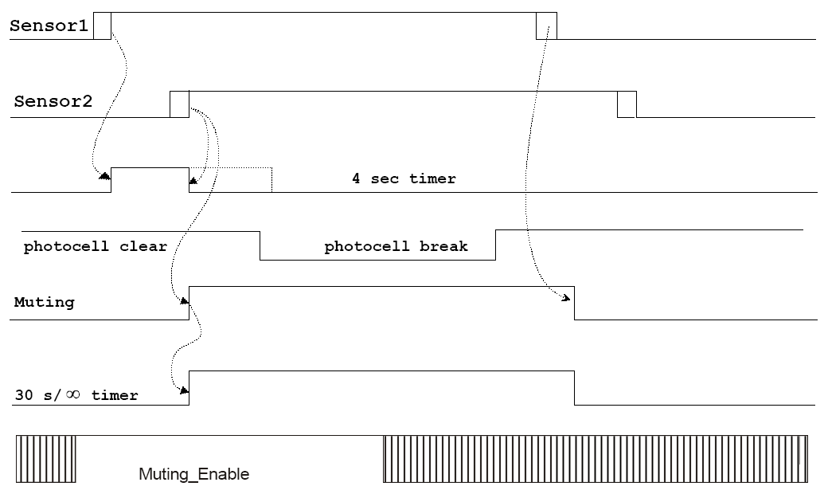
SENSOR 1
SENSOR 2
MUTING
FIELD FREE
FIELD INTERRUPTED
TIMER 4 SEC
Figure 16
Muting cycle

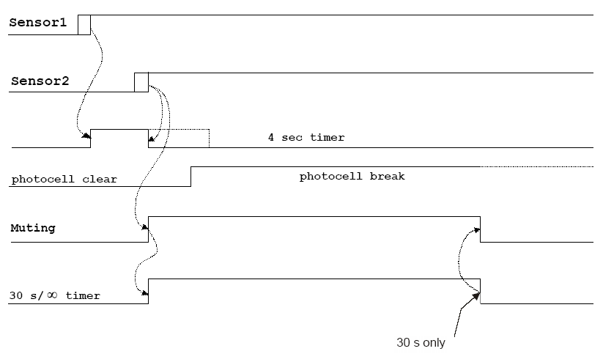
30s
SENSOR 1
SENSOR 2
MUTING
FIELD FREE
FIELD INTERRUPTED
TIMER 4 SEC
Figure 17
Muting cycle closed by a timeout

MUTING OVERRIDE FUNCTION
The OVERRIDE function must be used when the machine stops due to incorrect Muting activation sequences with the material obstructing the guarded opening.
In this situation, the OSSD outputs are not active as the photocell and/or at least one Muting sensor is occupied. In this condition the OVERRIDE request led blinks (ref. "Status Indicators").

- This function activates the OSSD outputs making it possible to remove the material that is obstructing the protected field; moreover the Muting lamp lights on.
- This operation must be executed under the control of an operator able to control its safety execution.
- During the installation of the AUS XM control unit be sure to avoid short circuits between the contacts 7 and 8.

The operator will use the Override mode previously selected.
- Override with maintained action control.
- Override with pulse control.

Override with maintained action control
This function is activated driving terminals 7 and 8 of the control unit to +24VDC at the same time (maximum delay = 400ms) using for example a 2-way key selector with spring return;

PIN 7 | PIN 8 | CONDITION
0 | 0 | Normal operation
24VDC | 24VDC | OVERRIDE request

The maximum override duration is 15 minutes; it can be stopped for two different causes.

- When the selector is released or if the 15 minutes has been elapsed, override ends, de-activating the OSSD outputs, turning off the muting lamp and showing normal condition on the display. A new override condition can be started, releasing and rearming the selector.
- Once the opening has been cleared and the sensors are free again, override ends and GUARD condition (control unit in normal operation) is activated without necessity of further commands.

Override with pulse control
This function is activated inverting (maximum delay = 400ms) the condition of pin 7 and 8 of the receiver using for example a push button (switch). During the override the 7 and 8 are not controlled.

PIN 7 | PIN 8 | CONDITION
0 | 24VDC | Normal operation
24VDC | 0 | OVERRIDE request

The maximum override duration is 15 minutes; it can be stopped for two different causes.

- When the 15 minutes has been elapsed, override ends, de-activating the OSSD outputs, turning off the muting lamp and showing normal condition on the display. A new override condition can be started with a new activation of the switch.
- Once the opening has been cleared and the sensors are free again, override ends and GUARD condition (control unit in normal operation) is activated without necessity of further commands.

SIGNALS DESCRIPTION
TERMINAL  NUMBER | SIGNAL  NAME | TYPE OF  SIGNAL | DESCRIPTION
1 | SENSOR 1 | Input | Muting Sensor n°1
2 | SENSOR 2 | Input | Muting Sensor n°2
3 | 24VDC | Input | Power supply 24Vdc
4 | TIMEOUT 1 | Input | Timeout selection n°1 *
5 | TIMEOUT 2 | Input | Timeout selection n°2 *
6 | MAN/AUTO | Input | Manual/Automatic configuration
7 | OVERRIDE 1 | Input | Override selection n°1 **
8 | OVERRIDE 2 | Input | Override selection n°2 **
9 | TEST_BARR1 | Output | Safety photocell number 1 TEST
10 | MUTING LAMP | Output | Muting lamp output
11 | MUTING ENABLE | Input | External muting enable input
12 | Relay B NO1 | Output | Safety relay B, contact 1 (N.O.)
13 | 0VDC | Input | Power supply 0Vdc
14 | PE | - | Ground connection
15 | RESTART | Input | Restart command Input
16 | SYSTEM_TEST | Input | Test of the system external request
17 | INPUT BARR1 | Input | Safety photocell number 1 status
18 | INPUT BARR2 | Input | Safety photocell number 2 status
19 | TEST_BARR2 | Output | Safety photocell number 2 TEST
20 | K1K2 (Feedback) | Input | K1K2 external contactors feedback
21 | SYSTEM STATUS | Output | Output safety relays status
22 | Relay B NO2 | Output | Safety relay B, contact 2 (N.O.)
23 | Relay A NO1 | Output | Safety relay A, contact 1 (N.O.)
24 | Relay A NO2 | Output | Safety relay A, contact 2 (N.O.)
Table 9

* REFER TO THE Table 10 FOR THE SELECTION OF THE MUTING TIMEOUT
Read carefully the "Muting sequence" section to select the right timeout
SELECTION OF THE MUTING TIMEOUT
TERMINAL 4 | TERMINAL 5 | TIMEOUT
0 Vdc | +24 Vdc | 30s
+24 Vdc | 0 Vdc | Infinite
0 Vdc | 0 Vdc | Conditions  not allowed
+24 Vdc | +24 Vdc | Conditions  not allowed
Table 10

** REFER TO THE Table 11 FOR THE SELECTION OF THE OVERRIDE
SELECTION OF THE OVERRIDE
TERMINAL 7 | TERMINAL 8 | OVERRIDE MODE
0 Vdc | 0 Vdc | Spring return key
0 Vdc | +24 Vdc | Push button
+24 Vdc | 0 Vdc | Conditions  not allowed
+24 Vdc | +24 Vdc | Conditions  not allowed
Table 11

The RESTART command
- The RESTART command must be sent to the control unit connecting terminal 15 to the +24Vdc.
- The contact used for the RESTART command must be able to switch a voltage of 24Vdc and a current of 20mA (guaranteeing a closing time > 100ms). This data is particularly important in the case of automatic management of sending of the RESTART command, for example using a PLC.
- The SYSTEM RESET TIME is obtained adding the reset time of any external contactors K1K2 to the reset time of the AUS XM control unit (100ms).
- In the case of manual activation, a normally open external button can be used, temporary closing of which generates the RESTART command.
- The Restart command must be installed outside the danger area in a position where the danger area and the entire work area concerned are clearly visible.
- It must not be possible to reach the control from inside the danger area.

The SYSTEM_TEST command
The SYSTEM_TEST command must be forwarded to the control unit connecting the terminal 16 to the +24Vdc.
The contact used for the SYSTEM_TEST command must be able to switch a current of 20mA and a voltage of 24Vdc (with a switching time of > 40ms). The AUS X control unit, after receiving this signal, provides to switch off the emitters of the connected safety photocells, THUS SIMULATING AN INTERCEPTION OF THE PROTECTED AREA.
The operator must verify the effective stopping of the hazardous machine (due to the de-activation of the control unit outputs) for all the time the SYSTEM_TEST command stays active.

- The effective stopping of the system must be verified by an operator and cannot be an operation of the control unit.

K1K2 FEEDBACK input
Using the K1 and K2 auxiliary safety contactors with guided contact safety type, it is necessary to connect the +24Vdc to the K1K2 FEEDBACK through the series of the K1-1 e K2-1 N.O. control contacts. The control of the correct switching of K1 and K2 is performed with a delay of 300ms after the real command.
When the K1-1 e K2-1 N.O. control contacts are not used (or no control is provided) it is mandatory to connect the terminal 20 (K1K2 FEEDBACK) to the terminal 21 (SYSTEM STATUS).

SYSTEM STATUS output
The SYSTEM STATUS output reports exactly the output safety relays status :
- When the output relays are opened, the SYSTEM STATUS reports 0VDC.
- When the output relays are closed, the SYSTEM STATUS reports +24VDC.

INSTALLATION AND ELECTRICAL CONNECTIONS
- Install the AUS XM control unit in an environment with a protection rating of at least IP54.
- If more modules AUS XM must be installed in the same board panel, in order to avoid overheatings, maintain between them one minimal distance of 2cm.
- The AUS XM control unit must be supplied with a 24Vdc ±20.
- The external power supply must comply with the standard EN 60204-1.
- During the installation of the AUS XM control unit be sure to avoid short circuits between the contacts 17 and 18.

Characteristics of the output circuit.
For the output circuit, the control unit uses two guided contact safety relays.
These relays are rated by the manufacturer for voltage and current values above those indicated in the technical data; however, to assure correct insulation and to avoid damage or premature aging, protect each output line with a 4A slow-blow fuse and check that load characteristics comply with the indications given in the table below.

Minimum switching voltage | 18 Vdc
Minimum switching current | 20 mA
Maximum switching voltage | 250Vac
Maximum switching current | 2A

Use of K1 and K2 auxiliary contact elements.
For loads with higher voltage and current characteristics than those indicated in the table above, use of auxiliary external relays or contactors suitable for the load to be controlled is recommended.
- The K1 and K2 auxiliary contactors or relays must be of the guided contact safety type.
- Referring to the table below, pay particular attention to the configuration of the control contacts on terminal 20 and that of the contacts of use.

 | Relay K1 | Relay K2
Control contacts | K1-1 normally closed | K2-1 normally closed
Use contacts | K1-2 normally open | K2-2 normally open

- Control contacts K1-1 and K2-1 (terminal 20) must be able to switch a current of 20mA and a voltage of 24Vdc.
- To increase the electrical life of internal relays A and B, it is advisable to use anti-disturbance devices which must be connected across the coils of K1 and K2.

Warnings regarding the connection cables.
- For light curtain/control unit connections of more than 50m, cables with a cross-section of at least 1mm² must be used.
- It is good practice to separate the power supply of the control unit from that of other electrical appliances (electrical motors, inverters, frequency variators) or other sources of disturbance.
- The path of the connection cables between the control unit ands the sensors, the connection referring to the test command and feedback contacts connected to terminal 20 must be different from that of other power cables.

STATUS INDICATORS
LED | COLOR | STATUS | DESCRIPTION
S1 | YELLOW | OFF | Muting sensor 1 free
S1 | YELLOW | ON | Muting sensor 1 interrupted
S2 | YELLOW | OFF | Muting sensor 2 free
S2 | YELLOW | ON | Muting sensor 2 interrupted
MUT | YELLOW | OFF | Correct operation
MUT | YELLOW | ON | Muting active
MUT | YELLOW | blinking | - Override request  - Muting fail (only with FAIL led ON) *
IN1 | Green | OFF | Photocell 1 interrupted
IN1 | Green | ON | Photocell 1 free
IN2  FAIL | Green  Red | OFF | Photocell 2 interrupted
IN2  FAIL | Green  Red | GREEN | Photocell 2 free
IN2  FAIL | Green  Red | RED | Failure detected *
GUARD  BREAK | Green  Red  YELLOW | GREEN | Output relays closed
GUARD  BREAK | Green  Red  YELLOW | RED | Output relays opened
GUARD  BREAK | Green  Red  YELLOW | RED blinking | The number of blinkings shows the  kind of FAIL (only with IN2/FAIL RED) *
GUARD  BREAK | Green  Red  YELLOW | YELLOW | Photocells free - Output relays opened  (only in manual operative mode)
Table 12
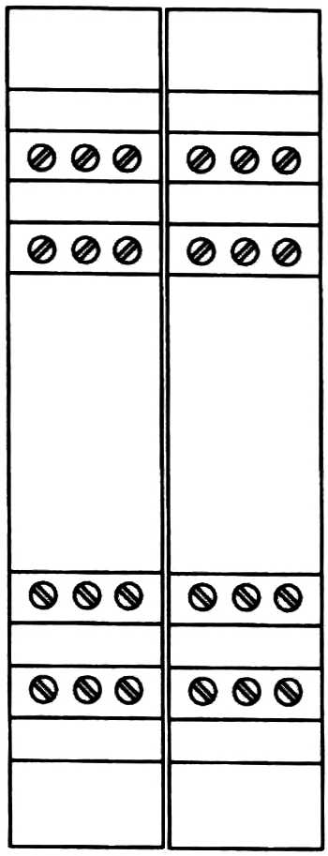
4 5 6 16 17 18
1 2 3 13 15
10 11 12 22 23 24
7 8 9 19 20 21
S1

S2

MUT.
AUS XM
IN1
IN2
FAIL
GUARD
BREAK

* REFER TO THE "FAULT DIAGNOSIS" SECTION TO HAVE A DETAILED EXPLANATION
OF THE POSSIBLE FAULT

DIMENSIONS
Figure 18
TECHNICAL DATA

Safety category |  | 2
Power supply | Vdc | 24 ± 20%
Power requirement | W | 5 max
Output | Relay | 2 N.O. contacts (2A; 250V)
Response time | ms | 30 max
Operating modes |  | Manual or Automatic, selectable  from terminal block
External relay control |  | 2 N.C. contacts (20mA; 24Vdc)
Number of connectable photocells |  | 1 ÷ 4
Muting sensors input |  | 2 sens. (24VDC; PNP; dark-on)
Muting enable input |  | 24VDC, PNP
Connections |  | Terminal block with protection  against reversal of polarity
Status indicators | Led | Power On – Photocell Status –  Fail - Muting active - Override active
Max. length of connections | m | 100
Operating temperature | °C | 0 ÷ 55
Enclosure protection rating |  | IP 20
Terminal block protection rating |  | IP 2X
Fastening |  | Fast attachment to rail according  to EN 50022-35
Dimensions (h x w x d) | mm | 99 x 35 x 114,5
Weight | g | 215

STATUS INDICATORS / FAULT DIAGNOSIS

Status indicators with 1 photocell connected

LED |  |  | MEANING
IN1  GREEN | IN2/FAIL  RED/GREEN | GUARD/BREAK  RED/GREEN | MEANING
ON | RED | RED | Power up test
OFF | OFF | RED | Photocell interrupted  Output relays opened
ON | OFF | YELLOW | Photocell free  Output relays opened
ON | OFF | GREEN | Photocell free  Output relays closed
System test | OFF | YELLOW: blinking 2 times per second | System test
Table 13

Status indicators with 2 photocells connected

LED |  |  | MEANING
IN1  (GREEN) | IN2/FAIL  (RED/GREEN) | GUARD/BREAK  (RED/GREEN) | MEANING
ON | RED | RED | Power up test
OFF | OFF | RED | Photocell interrupted  Output relays opened
OFF | GREEN | RED | Photocell interrupted  Output relays opened
ON | OFF | RED | Photocell interrupted  Output relays opened
ON | GREEN | YELLOW | Photocell free  Output relays opened
ON | GREEN | GREEN | Photocell free  Output relays closed
Shows the  photocell_1 status | Shows the  photocell_2 status | YELLOW: blinking 2 times per second | System test
Table 14

Status indicators (MUTING module)

LED |  |  | MEANING
S1 (YELLOW) | S2 (YELLOW) | MUTING (YELLOW) | MEANING
ON | ON | ON | Power up test
OFF | OFF | OFF | Both the sensors are free
ON | OFF | OFF | Sensor 1 interrupted
OFF | ON | OFF | Sensor 2 interrupted
ON | ON | ON | Muting active
Shows the  sensor_1 status | Shows the  sensor_2 status | Blinking | Override request
Table 15

Fault diagnosis

LED |  |  | MEANING
IN1  GREEN | IN2/FAIL  RED/GREEN | GUARD/BREAK  RED/GREEN (RED led pulses) | MEANING
OFF | ON | (2 pulses) | Possible fault to the Microcontroller board
OFF | ON | (3 pulses) | Internal relays fault
OFF | ON | (4 pulses) | K1K2 external relays fault
OFF | ON | (5 pulses) | User configuration failure
OFF | ON | (6 pulses) | User configuration  changed without system restart
OFF | ON | (7 pulses) | Possible overload or  SYSTEM STATUS connection error
Table 16

Fault diagnosis (modulo MUTING)

LED |  |  | SIGNIFICATO
S1  YELLOW | S2  YELLOW | MUTING  YELLOW | SIGNIFICATO
OFF | OFF | (2 pulses) | Bad connection of the muting lamp, lamp not present or in overload
OFF | OFF | (3 pulses) | Muting timeout  wrong configuration
OFF | OFF | (4 pulses) | Wrong override configuration at the power up
Shows the  sensor_1 status | Shows the  sensor_2 status | (5 pulses) | Instable muting Sensor

- If it is not possible to clearly identify the malfunction and to remedy it, stop the machine and contact Reer's Assistance Service.

GUARANTEE
REER warrants that each AUS X - AUS XM unit in new ex-factory condition, in conditions of normal use, is free of defects in the materials and of manufacturing defects for a period of 12 (twelve) months.
In this period, REER undertakes to eliminate any faults in the product through repair or replacement of the faulty parts, completely free of charge as regards material and labor.
However, REER reserves the right to replace the entire faulty appliance with another equivalent appliance or with the same characteristics instead of repairing this.
Validity of this warranty is regulated by the following conditions:
- The user must inform REER of the fault within twelve months from the date of delivery of the product.
- The appliance and its components must be in the conditions in which they were delivered by REER.
- The serial numbers must be clearly legible.
- The fault or defect has not been caused directly or indirectly by:
- Improper use;
- Non-compliance with instructions for use;
- Carelessness, inexperience, incorrect maintenance;
- Repairs, modifications, adaptations not carried out by REER personnel, tampering, etc.;
- Accidents or impacts (also due to transportation or causes of force majeure);
- Other causes not to be ascribed to REER.

Repairs will be carried out at the REER laboratories to which the material must be delivered or dispatched: transport risks and the risks of any damage or loss of the material during shipment are the responsibility of the user.
All products and components replaced become the property of REER.
REER does not recognize any other warranties or rights except for those specifically described above; therefore, no claims for damages may be submitted for expenses, interruption of business or other factors or circumstances in any way related to failure of the product or of one of its parts.

Precise, complete compliance with all the rules, instructions and prohibitions indicated in this handbook is an essential requirement for correct functioning of the control unit.
REER s.p.a. therefore declines any responsibility for all and anything resulting from failure to comply, even partially, with such indications.
Characteristics subject to change without notice. • Total or partial reproduction is forbidden without the prior authorization of REER.

